

Topic test 12
Name: __________________________________

Probability

• Time allowed: 45 minutes
• Part A: 20 multiple-choice questions (40 marks)
• Part B: 7 free-response questions (60 marks)
Part A
20 multiple-choice questions
2 marks each: 40 marks
Circle the correct answer.
1 Which of these terms best describes the chance
of rolling an even number on a die?
A likely B impossible
C unlikely D even chance
2 How many different outcomes are there when tossing a coin?
A 1 B 4
C 2 D 6
3 If the probability that it will snow tomorrow is 15%, what is the probability that it will not snow?
A 0% B 85%
C 30% D 45%
4 On this spinner, what is the probability of spinning a 2?
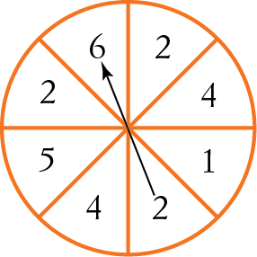
A 33% B 25%
C 37% D 66%
5 On the spinner in question 4, what is the probability of spinning a number less than 5?
A B
C D
6 For a family with two children, how many different arrangements of boys and/or girls (for example, boy–boy) are possible?
A 1 B 2
C 3 D 4
7 What is the probability that a person chosen
at random has a birthday in a month beginning
with M?
A B
C D
8 A meeting room contains 1 man, 5 women, 4 boys and 3 girls. What is the probability that a person chosen at random is a child?
A B
C D
9 If two coins are tossed, what is the probability that both show heads?
A B
C D
10 What is the probability of rolling 4 on a die?
A 0.4 B
C 0.25 D
11 Which one of the following could not be the probability of an event?
A 1 B 21
C 0 D 0.001
12 The set of all possible outcomes of a chance experiment is called the:
A experiment
B likelihood
C sample space
D complementary event
13 A whole number is chosen at random from the numbers 1 to 9. What is the probability that it is an odd number?
A B
C D
14 What is the probability that the number chosen in question 13 is a multiple of 3?
A B
C D
Questions 15 to 17 refer to the following frequency table that shows the number of heads and tails that resulted when a coin was tossed repeatedly.
Outcome | Frequency
Heads | 72
Tails | 28
15 How many times was the coin tossed?
A 100 B 2
C 50 D 72
16 What was the relative frequency of tails?
A 0.5 B 0.28
C 0.1 D 0.38

17 If the coin was tossed 300 times, how many tails would you expect?
A 28 B 150
C 50 D 84
Questions 18 to 20 refer to the choosing of a lolly at random from a jar containing 60 lollies coloured red, blue, yellow and green. The chance of choosing a red
lolly is . The chance of choosing a yellow lolly is .
18 What is the probability of drawing a red or yellow lolly from the jar?
A B
C D
19 What is the probability of drawing out a lolly that is neither red nor yellow?
A B
C D
20 Lara writes the probability of choosing a green lolly. Which one of these is a possible answer?
A B
C D

Part B
7 free-response questions
60 marks
Show your working where appropriate.
21 (6 marks) List the sample space of possible outcomes for each situation described below.
a The number of girls in a three-child family
____________________________________
____________________________________
b The answer to a multiple-choice question in Part A of this test
____________________________________
____________________________________
c The result of a driving test
____________________________________
____________________________________
22 (8 marks) A group of students was surveyed on whether they liked to listen to music (M) or play sport (S). The results are shown in this Venn diagram.
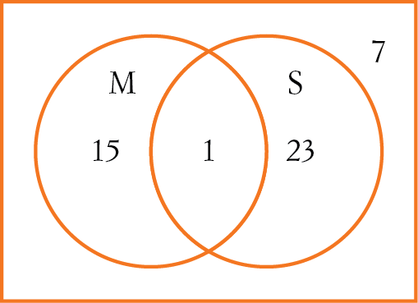
a How many students were surveyed?
____________________________________
b How many students don’t like music or sport?
____________________________________
c Find, as a simple fraction, the probability that a student chosen at random likes:
i music and sport _____________
ii music. _____________
23 (14 marks) The following data were collected about Year 9 students.
 | Left-handed | Right-handed
Male | 18 | 55
Female | 10 | 47

a How many Year 9 students were surveyed?
____________________________________
b How many students were left-handed?
____________________________________
c How many females were there?
____________________________________
d Find, as a simple fraction, the probability that a student chosen at random is:
i left-handed ______________
ii male ______________
iii female and left-handed ______________
iv female or left-handed. ______________
24 (12 marks) The numbers 4, 5, 6, and 7 are written on separate cards and placed in a bag. Two cards are drawn at random, one after the other without replacement, to form a two-digit number.
a Draw a tree diagram to show all possible two-digit numbers.
b Find the probability that the two-digit number formed:
i starts with a 6 _____________
ii is an even number _____________
iii is less than 70 _____________
iv is greater than 60 and divisible by 5.
_____________
25 (4 marks) From the letters of the word PARRAMATTA, one letter is chosen at random.
a What is the probability that the letter is an R?
_____________
b Which two letters are equally likely?
_____________
26 (6 marks) The chance of it raining on any November day is .
a What is the chance of it not raining on a November day? _____________
b How many days are there in November?
_____________
c On how many whole days in November would you expect it not to be raining?
_____________
27 (10 marks) This table shows the results of a survey about how students travel to school.
Transport | Frequency
Walk | 8
Bus | 21
Car | 16
Bike | 5

a How many students were surveyed?
_____________
b What is the probability that a student chosen at random from this survey travels by bike?
_____________
c What is the probability that a student chosen at random travels by car or bus?
_____________
d What is the complementary event to choosing a student who walks to school?
_____________
e If the school has 800 students, how many would you expect to travel by car?
_____________
This is the end of the test.
Use the rest of the page for extra working space.
Answers
1 D 2 C 3 B 4 C 5 A
6 D 7 C 8 B 9 B 10 D
11 B 12 C 13 D 14 C 15 A
16 B 17 D 18 C 19 B 20 D
21 a 0, 1, 2, 3 b A, B, C, D c pass, fail
22 a 55 b 7 c i ii
23 a 130 b 28 c 57
d i ii iii iv

24 a
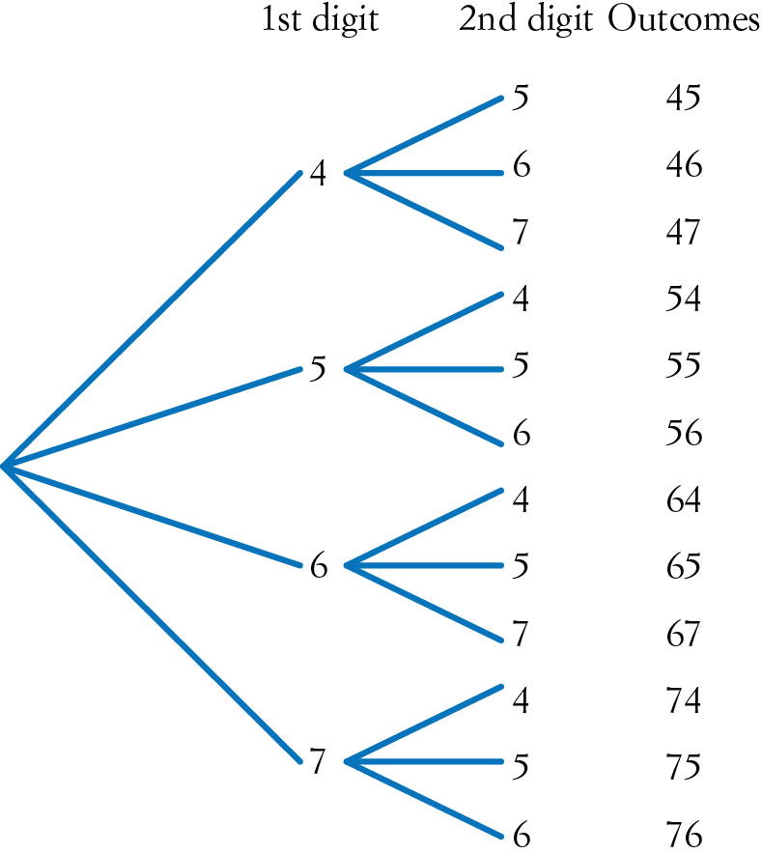

b i ii iii iv
25 a b R and T (or P and M)
26 a b 30 c 19
27 a 50 b c
d choosing a student who doesn’t walk to school
e 256

