

Topic test 11
Name: __________________________________

Coordinate geometry

• Time allowed: 45 minutes
• Part A: 20 multiple-choice questions (40 marks)
• Part B: 12 free-response questions (60 marks)
Part A
20 multiple-choice questions
2 marks each: 40 marks
Circle the correct answer.
Questions 1 to 3 refer to the line graphed below.
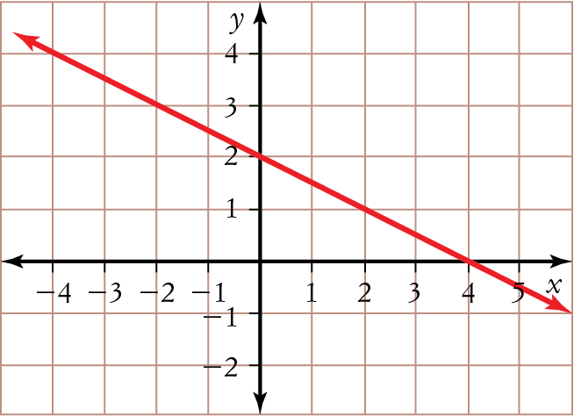
1 Which point does not lie on the line?
A (3, 1) B (−2, 3) C (2, 1) D (0, 2)
2 What is the x-intercept of the line?
A 2 B −2 C 4 D −4
3 What is the gradient of the line?
A − B C −2 D 2
4 What is the equation of the line graphed below?
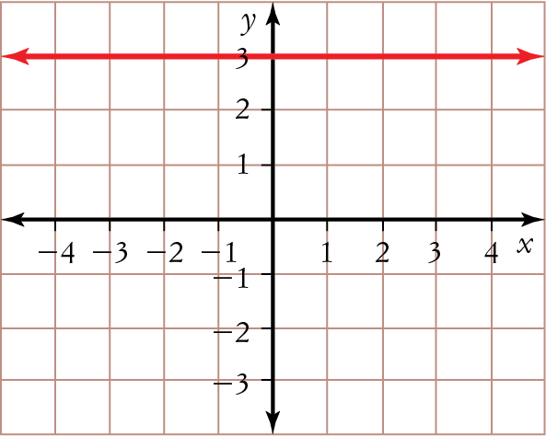
A x + y = 3 B x = 3
C y = x + 3 D y = 3
5 Which one of these lines has the smallest gradient?
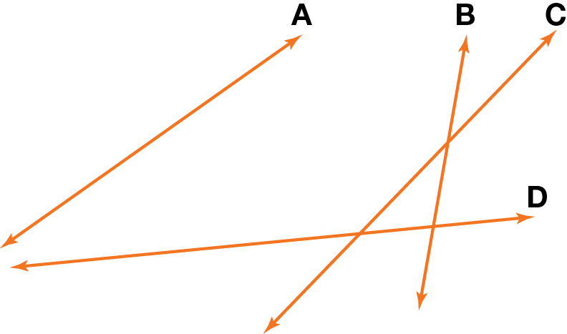
Questions 6 to 8 refer to the triangle on the section of a number plane shown below.
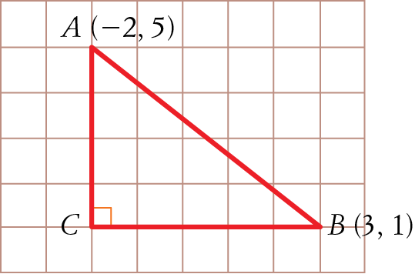
6 If ∆ABC is right-angled at C, what are the coordinates of C ?
A (5, 4) B (1, 4)
C (3, 5) D (−2, 1)
7 What is the length of CB?
A 5 units B 1 unit
C 3 units D 2 units
8 Find the length of AB.
A 9 units B units
C units D units
9 The line x = −1:
A has a negative gradient
B is vertical
C is horizontal
D has a y-intercept of −1
10 If y = 3x − 7, find y when x = 2.
A 1 B 2
C −1 D −2
11 Find the midpoint of KL.
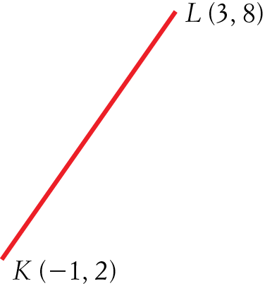
A (−2, −3) B (−2, 5)
C (1, 5) D (1, 3)
12 Find the length of KL, shown in question 11.
A 1.5 units B 7.21 units
C 4.47 units D 3.16 units
13 Which one of these points lies on the line y = 2x − 5?
A (3, 0) B (2, −2)
C (−2, −9) D (−1, 5)
14 Which one of these lines has a negative gradient?
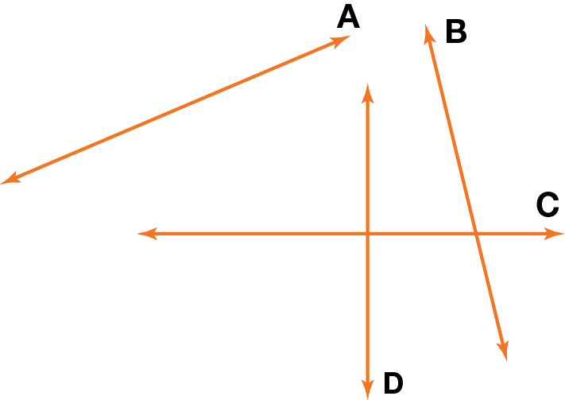
15 Find the gradient of the interval joining
R(−3, 3) and S(7, 1).
A − B −5
C − D −
16 What is the correct expression for the gradient of the interval joining points (1, 7) and (4, 2)?
A m = B m =
C m = D m =
17 N varies directly with m. If m = 6 and N = 96, what is the value of the constant of variation, k?
A 0.0625 B 16
C 102 D 576
18 Interval FG has endpoints F (1, −7) and G (4, 3). What is the midpoint of FG?
A (2.5, −2) B (3, 3.5)
C (2, −1.5) D (1.5, 5)
19 What is the length of FG in question 18.
A units B units
C 3 units D units
20 Which one of these could be the graph
of y = −3x2?
A B
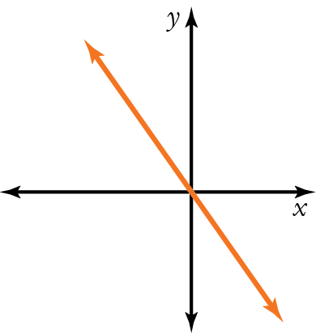
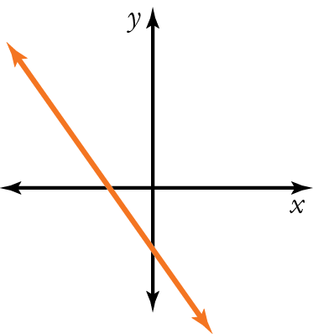

C D
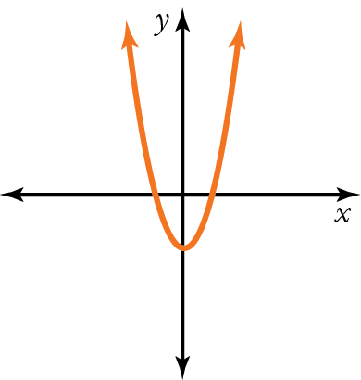
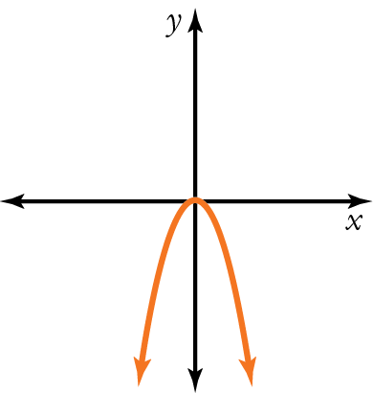

Part B
12 free-response questions
60 marks
Show your working where appropriate.
21 (4 marks) Complete this table of values and graph y = 2x − 3 on the axes below.
x | −1 | 0 | 1 | 2
y
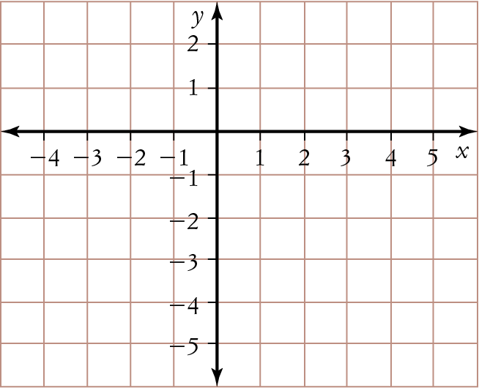

22 (7 marks) The points P(−2, 4) and Q(1, 0) are graphed below.
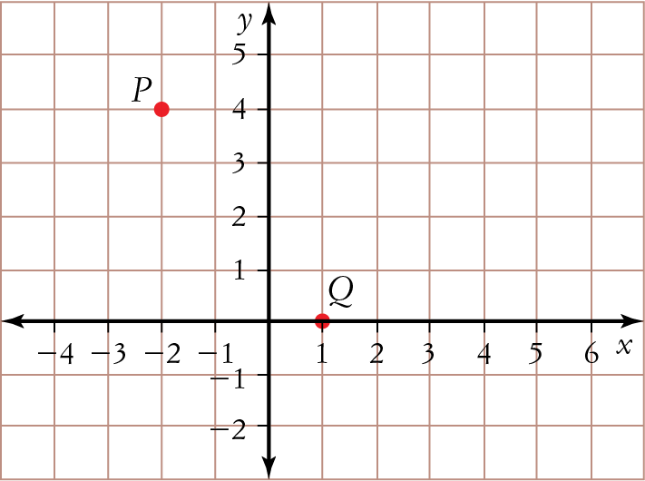
a Calculate the distance between P and Q.
_____________________________________
_____________________________________
_____________________________________
b Find the coordinates of the midpoint of PQ.
_____________________________________
_____________________________________
c Calculate the gradient of PQ.
_____________________________________
_____________________________________
23 (4 marks) Test whether the point (4, −3) lies on the line:
a y = 3x − 10
_____________________________________
_____________________________________
b x + 2y = −2
_____________________________________
_____________________________________
24 (3 marks) Find the equation of this line.
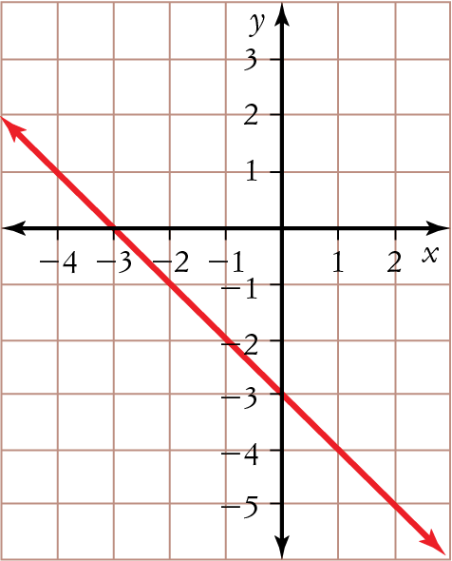
_____________________________________
_____________________________________
25 (2 marks) Sketch a parabola that is concave down with a vertex at (0, 3).
26 (8 marks)
a Graph and label the lines y = 2x + 5 and y = −x − 1 on the number plane below.
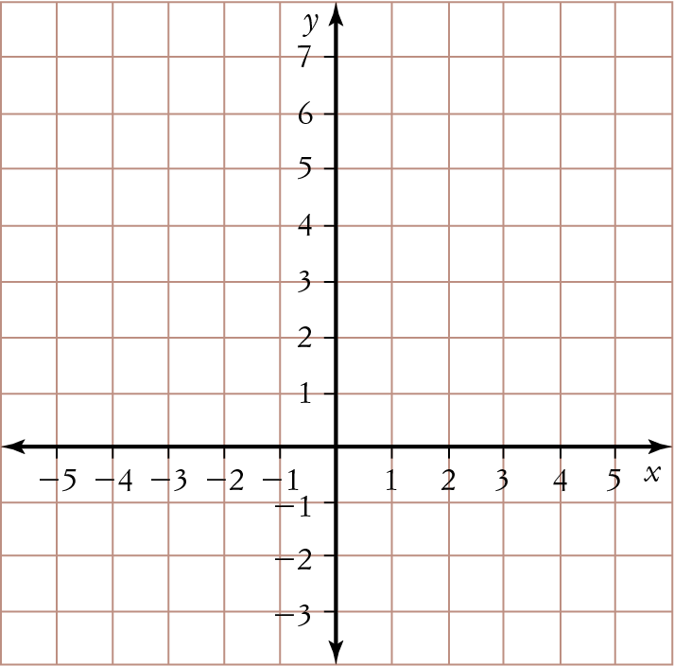
b Write the coordinates of the point of intersection of the two lines.
_____________________________________
27 (4 marks) p varies directly with r. If r = 7 and
p = 9.8, find p when r = 11.
_____________________________________
_____________________________________
_____________________________________
_____________________________________
28 (8 marks)
a Use a table of values to help you draw the graph
of y = 2x2
_____________________________________
b Is the graph you drew for part a concave up or concave down?
_____________________________________
c What is the vertex of the graph you drew for part a?
29 (2 marks) Describe what a line with zero gradient looks like.
_____________________________________
_____________________________________
30 (6 marks) For the circle with equation x2 + y2 = 64:
a find the coordinates of its centre.
_____________________________________
b find the length of its radius
_____________________________________
c sketch its graph.
31 (6 marks) Find the perimeter of the parallelogram ABCD.
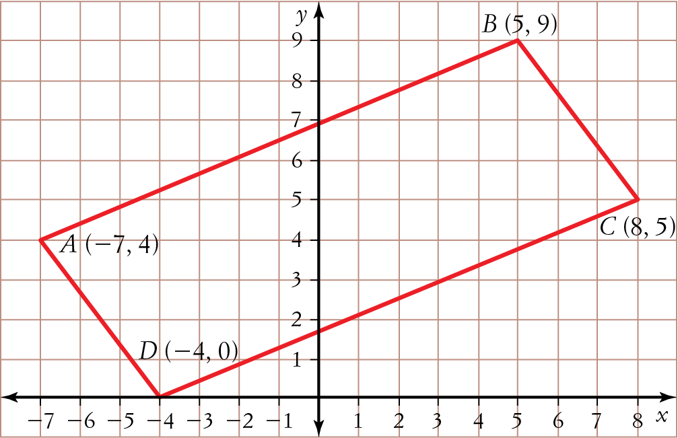
_____________________________________
_____________________________________
_____________________________________
_____________________________________

32 (6 marks)
a Draw a line with a gradient of −1 and a
y-intercept of −1.
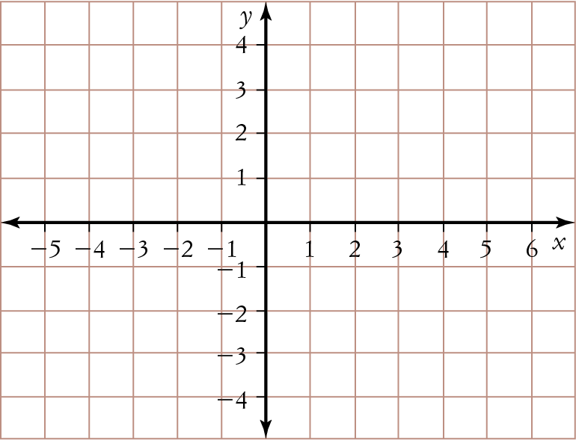
b Find the equation of the line you drew in
part a.

This is the end of the test.
Use the rest of the page and the back for extra working space.
Answers
1 A 2 C 3 A 4 D 5 D
6 D 7 A 8 D 9 B 10 C
11 C 12 B 13 C 14 B 15 C
16 D 17 B 18 A 19 D 20 D
21 −5, −3, −1, 1
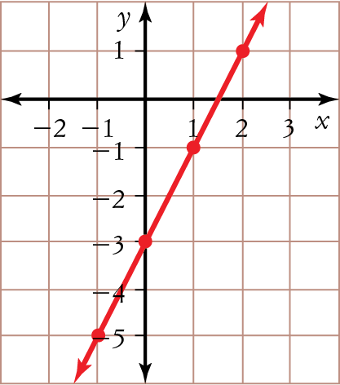
22 a 5 units b (−, 2) c −
23 a no b yes
24 y = −x − 3
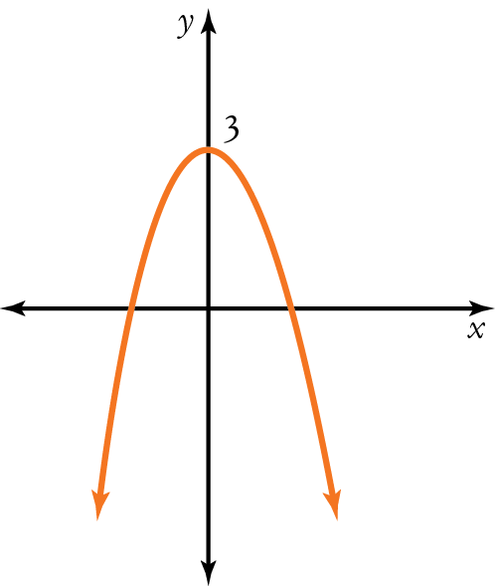
25

26 a
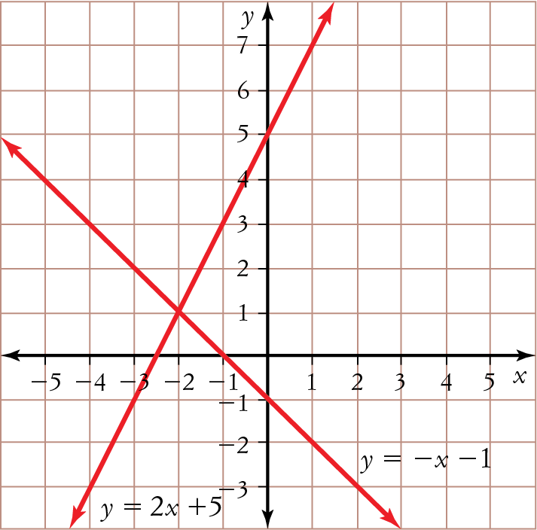

b (−2, 1)
27 p = 15.4
28 a
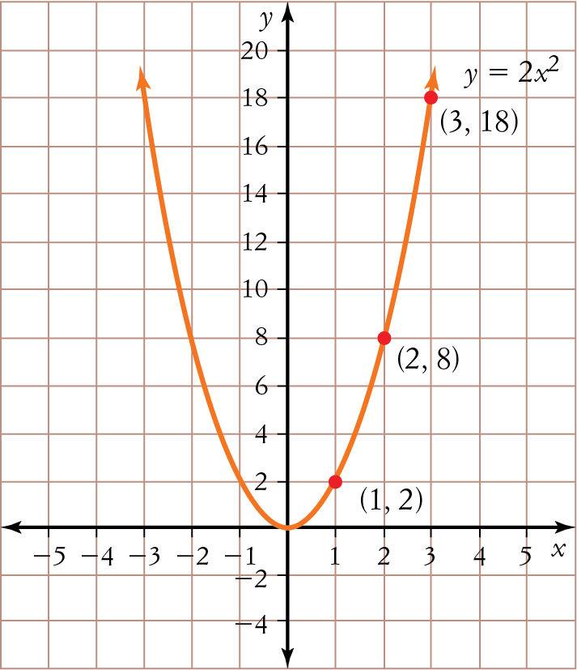

b concave up c (0, 0)
29 It is horizontal because it has no steepness (gradient).
30 a (0, 0) b 8 cm
c
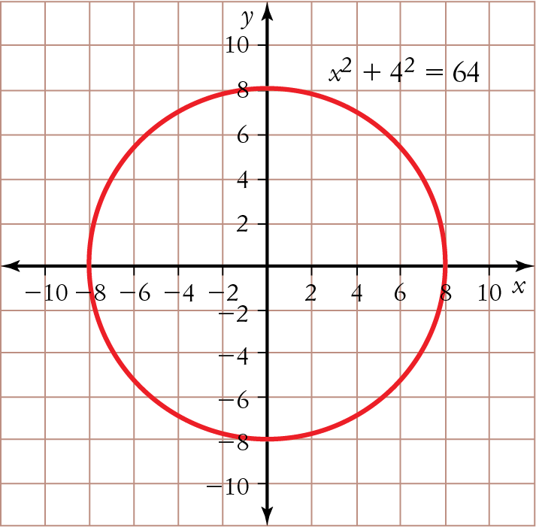

31 36 units
32 a
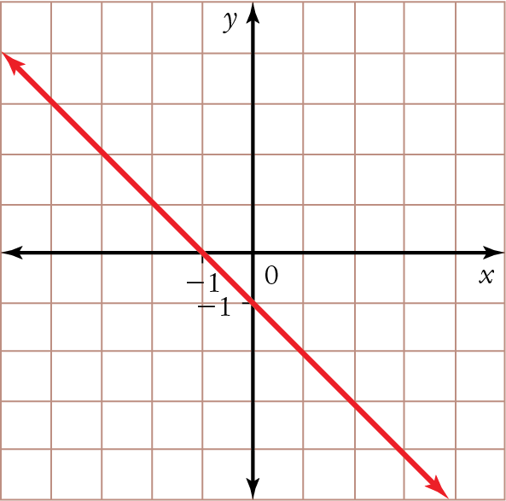

b y = −x − 1

