

Topic test 6
Name: __________________________________

Geometry

• Time allowed: 45 minutes
• Part A: 20 multiple-choice questions (40 marks)
• Part B: 15 free-response questions (60 marks)
Part A
20 multiple-choice questions
2 marks each: 40 marks
Circle the correct answer.
1 What is the value of x in this diagram?
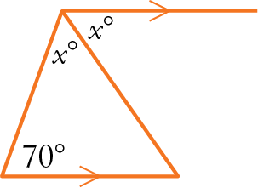
A 55 B 35
C 70 D 110
2 What is the value of a in this diagram?
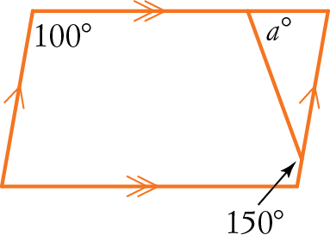
A 100 B 70
C 90 D 50
3 What is the size of ∠PQR?
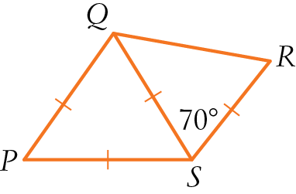
A 130° B 115°
C 140° D 125°

4 How many axes of symmetry has a rhombus?
A 0 B 1
C 2 D 4
5 What is the angle sum of a pentagon?
A 450° B 500°
C 540° D 900°
6 What is the value of y in this diagram?
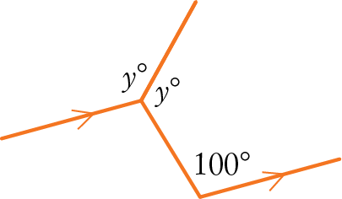
A 100° B 80°
C 140° D 130°
7 What is the value of d in this diagram?
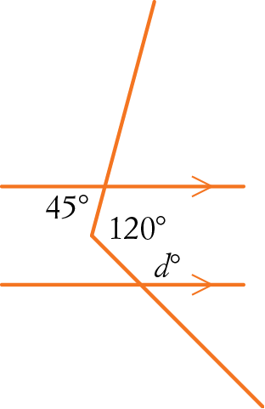
A 75 B 105
C 135 D 165
8 What is the value of b in this diagram?
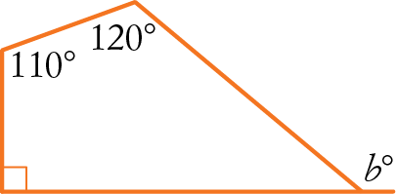
A 40 B 120
C 140 D 200

9 What is another name for a regular quadrilateral?
A rhombus B rectangle
C square D isosceles trapezium
10 According to the exterior angle rule, which of the following statements about this triangle is true?
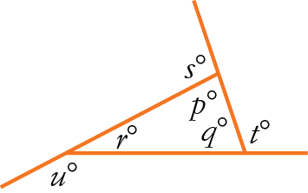
A s = p + q B u = q + p
C t = u + s D t = p + q
11 What angle size is complementary to x°?
A x° − 90° B 90° − x°
C x° − 180° D 180° − x°
12 What is the value of r in this diagram?
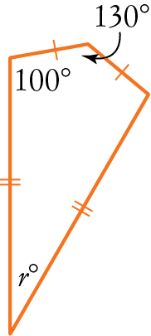
A 65 B 30
C 50 D 100
13 What is the value of x in this diagram?
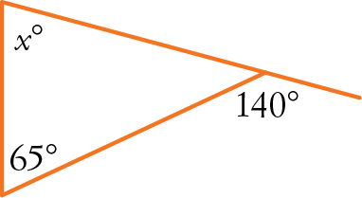
A 15° B 40°
C 75° D 65°

14 Which one of these statements about properties is false about a parallelogram?
A Opposite angles are equal.
B Diagonals are equal.
C Opposite sides are equal.
D Opposite sides are parallel.
15 What angle size is supplementary to y°?
A y° − 180° B 90° − y°
C y° − 90° D 180° − y°
16 An isosceles triangle has an angle size of 70°. Its other two angles could be:
A 55°, 55° B 70°, 50°
C 40°, 40° D 50°, 60°
17 Which of the following statements is true about this diagram?
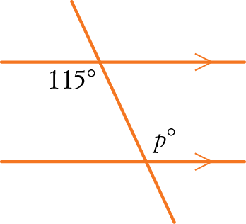
A p = 65 (alternate angles on parallel lines)
B p = 65 (co-interior angles on parallel lines)
C p = 115 (alternate angles on parallel lines)
D p = 115 (co-interior angles on parallel lines)
18 PQRS is a rectangle. ST bisects ∠PSR. Find the value of r.
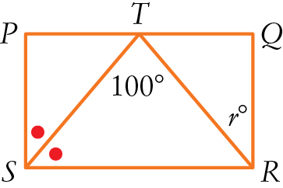
A 50 B 35
C 45 D 55

19 What is the value of x in this diagram?
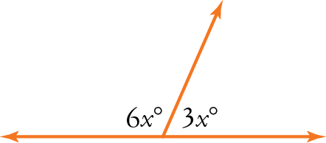
A 120 B 90
C 20 D 10

20 Which of the following statements is true?
A A trapezium is a rhombus.
B A rectangle is a square.
C A parallelogram is a rhombus.
D A rectangle is a parallelogram.
Part B
15 free-response questions
60 marks
Show your working where appropriate.
21 (4 marks)
a Sketch an equilateral triangle with an exterior angle.

b What is the size of the exterior angle on your diagram for part a?
____________________________________
22 (6 marks)
a Write one property of the:
i sides of a parallelogram
_________________________________
ii angles of a parallelogram
_________________________________
iii diagonals of a parallelogram
_________________________________
b Sketch a parallelogram, showing the properties you described in part a.

23 (6 marks) Find the value of each pronumeral in the diagrams below.
a
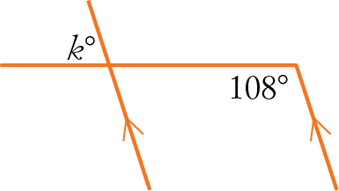
k = ___________________
b
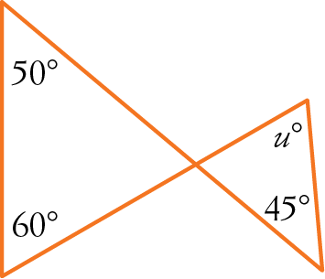
u = ___________________
c
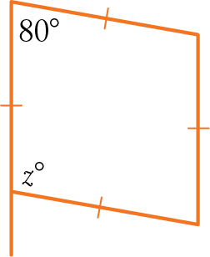
z = ___________________
24 (2 marks) Draw an irregular pentagon.

25 (2 marks) Draw a non-convex pentagon.

26 (4 marks)
a Find the sum of the angles of this regular hexagon.
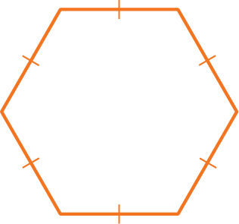 _________
b Find the size of one angle in the regular hexagon. _________
27 (3 marks) ABCD is a square. Find the value of h, giving reasons.
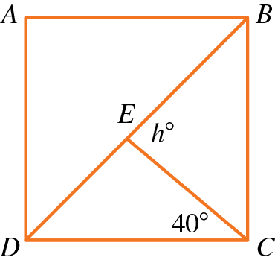
____________________________________
____________________________________

28 (4 marks)
a What is the definition of a rectangle?
____________________________________
____________________________________
b What is special about the diagonals of a rectangle?
____________________________________
____________________________________
29 (6 marks) Find the value of each pronumeral in the following diagrams.
a
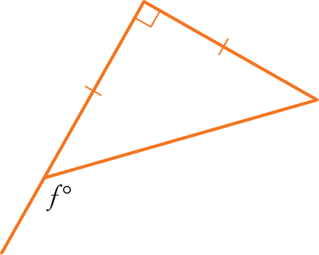
____________________________________
____________________________________
b
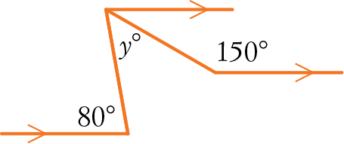
____________________________________
____________________________________
c
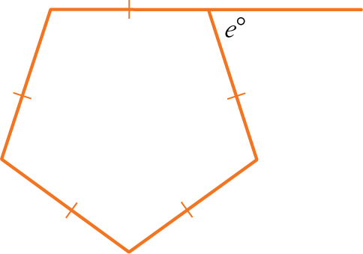
____________________________________
____________________________________

30 (2 marks) What is the difference between a rhombus and a square?
____________________________________
____________________________________
31 (8 marks) Consider this triangle with interior angles a°, b°, c° and exterior angles x°, y°, z°.
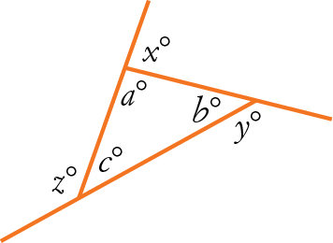
a What is the value of a + b + c?
_________________________________
b What is the value of a + x?
_________________________________
c What is the value of a + x + b + y + c + z?
_________________________________
d Hence find the value of x + y + z, showing working.
_________________________________
_________________________________
32 (4 marks) Name the most general quadrilateral with:
a one pair of opposite sides parallel
_________________________________
b both pairs of opposite angles equal
_________________________________

33 (3 marks) Find the value of n in the diagram below, giving reasons.
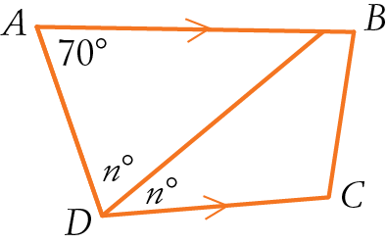
____________________________________
____________________________________
____________________________________
____________________________________
34 (3 marks) Find the value of y in the diagram below, giving reasons.
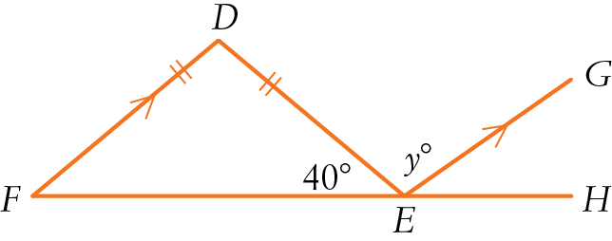
____________________________________
____________________________________
____________________________________
____________________________________
35 (3 marks) Each angle in a regular polygon is 140°. How many sides has the polygon?
____________________________________
____________________________________
____________________________________
____________________________________
This is the end of the test.
Use the rest of the page and the back for extra
working space.

Answers
1 A 2 B 3 B 4 C 5 C
6 D 7 B 8 C 9 C 10 B
11 B 12 B 13 C 14 B 15 D
16 A 17 C 18 D 19 C 20 D
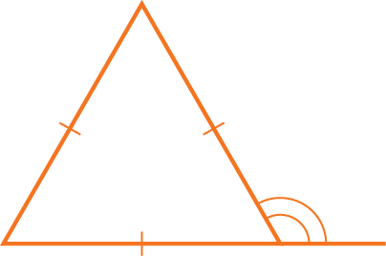
21 a b 120°
22 a i Opposite sides parallel (or equal)
ii Opposite angles equal
iii Diagonals bisect each other
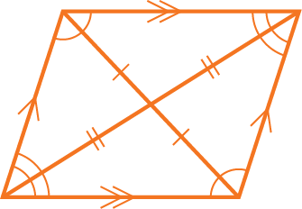
b
23 a k = 72 b u = 65 c z = 100
24 Example only. Teacher to check.

25 Example only. Teacher to check.

26 a 720° b 120°
27 ∠EDC = 45° (diagonal BD bisects the right angle of the square)
h = 40 + 45 = 85 (exterior angle of ΔECD)
28 a A quadrilateral with four right angles, or a parallelogram with a right angle
b Diagonals are equal
29 a f = 135 b y = 50 c e = 72
30 A rhombus and a square both have all sides equal, but a square also has all angles equal (90°).
31 a 180 b 180 c 540 d 360
32 a trapezium b parallelogram
33 n = 55
34 y = 100
35 9 sides

